Date 28/Junly/2019

Object recognition pipeline for smart farming

Object Recognition team 2

Software COde Architecture

## Folder overview

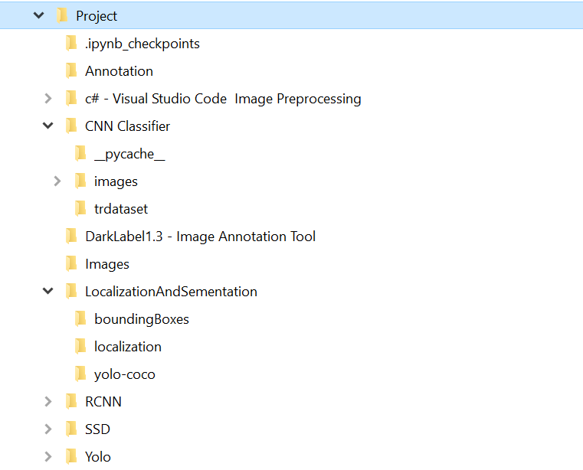Code Structure

| Name | Functionality |
| --- | --- |
| Annotation | Annotation Text File + Source Code |
| C# - Preprocessing | Put all files in one directory |
| CNN Classifier | Classify the images from directory  ( **LocalizationAndSementation\localization** )  to  (**CNN Classifier\images**) - COW / NOT COW |
| LOCALISATION AND SEGMENTATION | Using the best model i.e. YOLO. We are doing localization and segmentation and saving them in folder boundingBoxes and localization |
| RCNN | Model + Source Code |
| SSD | Model + Source Code |
| Yolo | Model + Source Code |
|  |  |

## SET UP PROCESS

### Working Mechanism

Every code has its description related to its functionality.

### Important (SET UP PATH)

Please set the path if required in the code (Spyder, we all were having path issue while executing)

i.e. os.chdir("C:\\Users\\SouravKr\\Music\\Project\\Project")

### Working Flow Steps

Step 1:

Put all images in one folder

Step 2:

Individually Compute the 3 Models

Step 3:

Make Annotation of random Images

Step 4:

Compare the Models with Analysis part

Step 5:

Localization And Segmentation - Yolo Computation

Step 6 :

CNN Keras.io Classifier

## Project Plan

| Name | Module | File Name |
| --- | --- | --- |
| Akhila | YOLO | Yolo.py |
| Swathi | MASK RCNN | maskrcnn.py |
| Mounika | ANNOTATION | annotation.py |
| Sruthin | SSD | ssdcode.py |
| Sourav | Comparison + IOU | Image_ShowComparison_Yolo,_RCNN,_SDD_.ipynb |
| Sourav | Keras Classifier | mobnet.py, **test**_kerasnetwork.py, **train**_kerasnetwork.py |
| Mounika + Akhila | YOLO SEGMANTATION | yolo_seg_loc.py |
| Sruthin + Swathi | Preprocessing C# | program.cs |

Python Libraries

* **For MASK RCNN Require Python environment has OpenCV 3.4.2/3.4.3 or higher**

**Please find requirements.txt in home directory**

## Output:

Yolo : Yolo.py

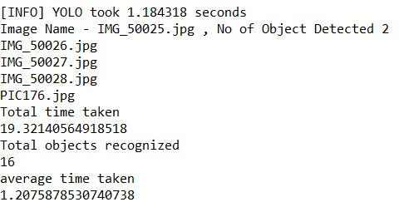

SSD : **ssdcode.py**

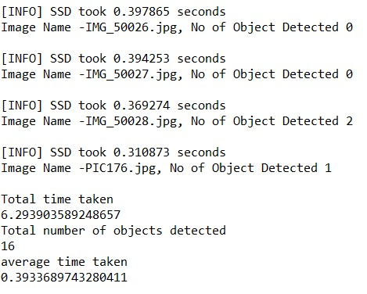

Mask RCNN : **maskrcnn.py**

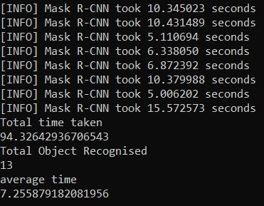

Comparison

Yolo – red color

SSD – blue color

Mask RCNN - blue color

